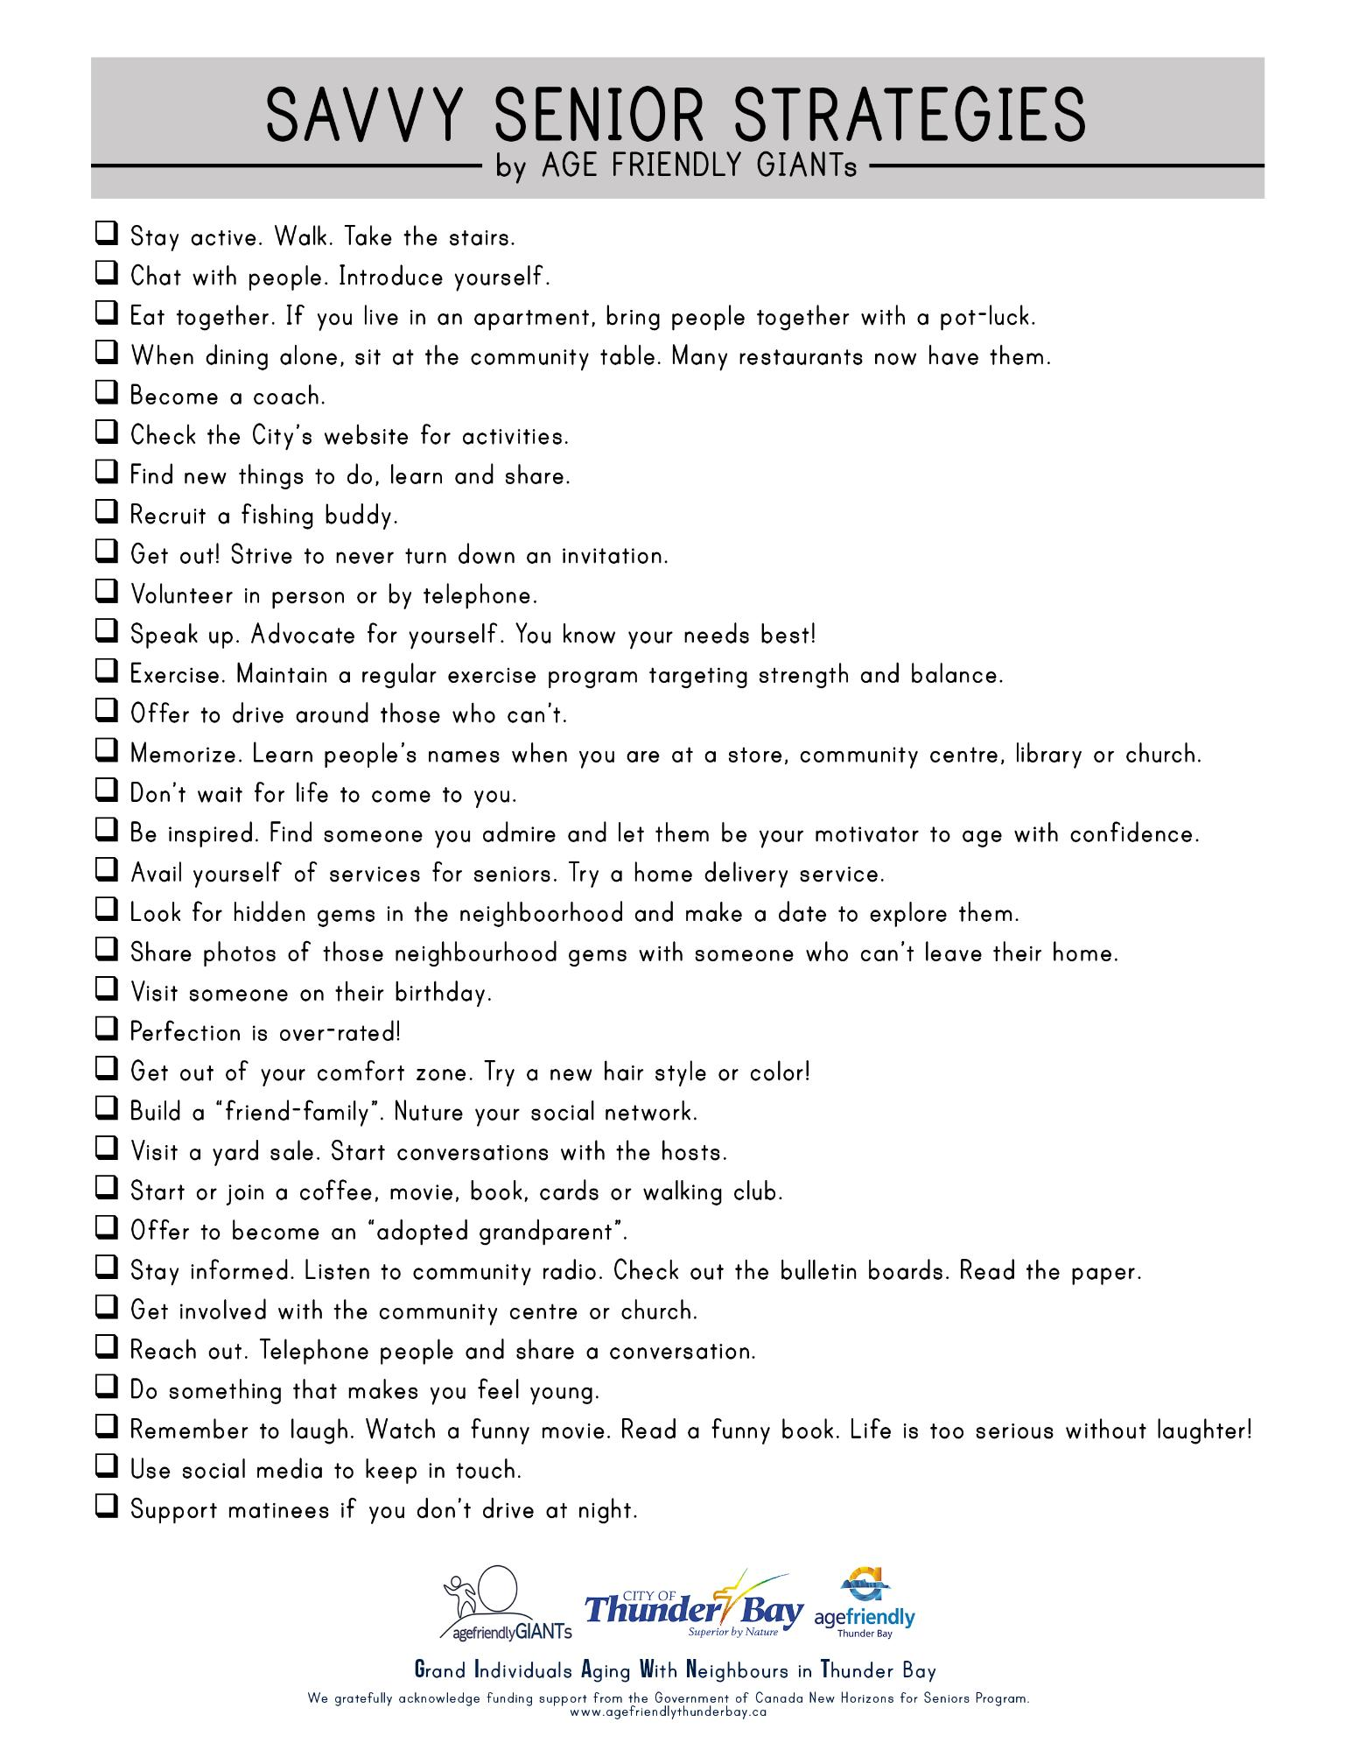
SAVVY SENIOR STRATEGIES
– by AGE FRIENDLY GIANTS
Stay active. Walk. Take the stairs. Chat with people. Introduce yourself. Eat together. If you live in an apartment, bring people together with a pot-luck. When dining alone, sit at the community table. Many restaurants now have them. Become a coach. Check the City's website for activities. Find new things to do, learn and share. Recruit a fishing buddy. Get out! Strive to never turn down an invitation. Volunteer in person or by telephone. Speak up. Advocate for yourself. You know your needs best! Exercise. Maintain a regular exercise program targeting strength and balance. Offer to drive around those who can't. Memorize. Learn people's names when you are at a store, community centre, library or church. Don't wait for life to come to you. Be inspired. Find someone you admire and let them be your motivator to age with confidence. Avail yourself of services for seniors. Try a home delivery service. Look for hidden gems in the neighboorhood and make a date to explore them. Share photos of those neighbourhood gems with someone who can't leave their home. Visit someone on their birthday. Perfection is over-rated! Get out of your comfort zone. Try a new hair style or color! Build a “friend-family". Nuture your social network. Visit a yard sale. Start conversations with the hosts. Start or join a coffee, movie, book, cards or walking club. Offer to become an “adopted grandparent". Stay informed. Listen to community radio. Check out the bulletin boards. Read the paper. Get involved with the community centre or church. Reach out. Telephone people and share a conversation. Do something that makes you feel young. Remember to laugh. Watch a funny movie. Read a funny book. Life is too serious without laughter! Use social media to keep in touch. Support matinees if you don't drive at night.
CITY OF
Thunder Bay agefriendly
Superior by Nature
Thunder Bay
agefriendlyGIANTS
Grand Individuals Aging With Neighbours in Thunder Bay We gratefully acknowledge funding support from the Government of Canada New Horizons for Seniors Program.
www.agefriendlythunderbay.ca

